NLP Model Comparison for Text Classification

Introduction
Natural Language Processing (NLP) allows machines to comprehend textual or spoken language, its uses include; classifying the feeling of messages, filtering emails and classifying medical documents. Text categorization is among the most important areas in NLP which identifies the text with a given set of labels, the most popular of which is sentiment analysis. Sentiment analysis of customer feedback, reviews, and social media can help many businesses and organizations to gather useful information.
In this report the upstream task involves Sentiment Classification using IMDB Movie Reviews database, comprising of 50,000 labeled reviews, with positive as well as negative sentiment. We comparatively analyze classical approaches like Naive Bayes to new innovative tech like Deep Learning with LSTM. Long short-term memory networks are strongly suitable for determining long-term dependencies and are used as one of the most effective architectures in sentiment analysis.
Boosted by such models, more recent architectures known as Transformers such as BERTs capture self-attention mechanisms among inputs making it easier to capture the relationships within text. Recent transformer models have raised the bar on the performance achieved on NLP tasks such as sentiment analysis by improving sample learning from data. This paper aims to understand the effectiveness of the traditional models, LSTMs, and Transformers for sentiment classification so as to recommend the most effective model to be used within such context.

Background Review
Text classification has emerged as an essential component of the Natural Language Processing (NLP) fields and its subsets and uses include spam detection and sentiment analysis, medical records’ classification, as well as product recommendation systems among others. Initial approaches employed both the BoW matrix representation and based their opinions on Naive Bayesian classifiers. Even though all these methods provided efficient computational solutions for the tasks, they were not very effective in handling semantic relocations and a context within the text. For example, BoW models were used as benchmark for sentiment classification by Pang and Lee (2008) while they performed poorly when confronted with tasks that needed higher level of context awareness.
Deep learning started a significant disruption in the text classification field. RNNs, especially LSTMs, enhanced substantial progression through the introduction of the sequence of text. Different from other RNNs, LSTMs solve the vanishing gradient problem, which is inherent in standard RNNs, and conduct well in modeling long-term dependencies (Bengio et al., 2003). This capability is especially important for operations like the sentiment analysis one, where actual connectivity between words in a sentence is normally more relevant than the meaning of concrete words.
But even more recently, architectures that adhere to the attention, including Transformers, have extended the horizons of text classification even further. Vaswani et al. (2017) proposed the Transformer model as a replacement of recurrence for handling of text sequences in parallel as well as performance enhancement. One of the significant advantages of the models is to represent the current context and to cope with polysemous meanings and the contexts involved in it, which has been unreachable to achieve using traditional models.
Nonetheless, similarities in these types of rooms still exist and several issues are still present. Usually, deep learning models are resource-demanding mainly in terms of time for training and testing. Moreover, their tendency to memorise the small training sets requires fine-tuning, and in some cases, big labelled datasets are required. One major issue that further research is still needed in is generalization ability, especially when it is confined under low resource scenarios (Howard & Ruder, 2018).

Objectives
The objectives of this study align with SMART principles:
- Specific: Compare two of the traditional ML models and two out of the deep learning models on the same text classification task.
- Measurable: For a performance measure use accuracy, F1-score, and AUC.
- Achievable: Build on existing data and use software tools and methods that are available to everyone.
- Relevant: Evaluete how feasible these models are on practical sentiment analysis.
- Time-bound: Finally, conduct the analysis within a prescribed duration of a project.

Dataset Description
The IMDB Movie Reviews dataset is an undoubtedly familiar and established NLP dataset, especially in movie review sentiment analysis. It has 50,000 movie reviews with equal proportional split of positive and negative polarity (Maas et al., 2011). This balance helps to provide the dataset for binary classification tasks optimal, as well as excluding inherent problems of class imbalance that can distort the results of the work of Ml models. All the reviews look at real user representations characterized by different linguistic attitudes as well as genuine sentiment patterns.
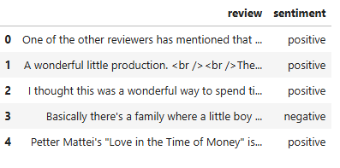
Figure 1 : Dataset Description

Strengths of the Dataset
- Structured Format:
Available in a format friendly of loading and preprocessing: a parseable CSV file, capable of incorporating into the machine learning processes (Maas et al., 2011).
- Balanced Distribution:
The ratio of positive and negative reviews being fairly even, the dataset allows for genuinely chasing the signal chance of the model and reducing overfitting hazards (Vaswani et al., 2017).
- Preprocessing Readiness:
The structure of a review is simple hence orientating most preprocessing stage such as tokenization, stemming and removal of punctuation hence enabling compatibility with the vectorization techniques.
Weaknesses of the Dataset
- Linguistic Noise:
The online reviews are written in plain English, containing slang, misspellings and informal language, they may moderate the results of the models that are sensitive to the tables in text (Pang & Lee, 2008).
- Contextual Limitations:
Due to the absence of information like the age, gender, nationality, and the movies’ genres of the reviewers, the dataset narrows down the ability to examine sentiment shifts across one class or the other (Howard & Ruder, 2018).
- Domain-Specific Bias:
While being specific to movie reviews, the dataset may not hold well for other domains of sentiment analysis for example; product reviews or social media data (Devlin et al., 2019).

Exploratory Data Analysis (EDA)
The first impression of the IMDB Movie Reviews dataset that was gained was that the dataset contains fifty thousand reviews with equal numbers of positive and negative sentiments. The average length of all the reviews is about 200 words; however, there are some reviews that are considerably longer and need preprocessing to be used with deep learning AI systems. Whereas phrasing, word clouds appeared as indicated the most frequently used terms including, great, movie, plot as well positive and negative sentiments including, amazing and boring respectively. This balance makes the evaluation of models rather easy since one cannot have to use other methods such as oversampling or undersampling. The observations derived from the analysis help in developing robust theoretical frameworks for constructing sentiment classification models.
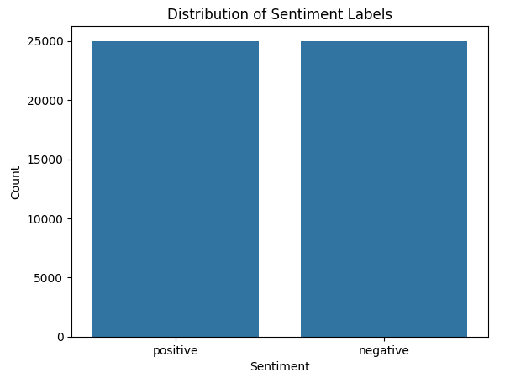
Figure 2 : Distribution of Sentiment Labels
Preprocessing Steps
Comprehensive preprocessing steps were implemented to prepare the dataset for machine learning and deep learning models:
Tokenization:
To perform TTR the text reviews were preprocessed and tokenized using TensorFlow tokenizer. This step further divided each review into a set of tokens, which helps in transforming text data into a format which can be used by the computational model.
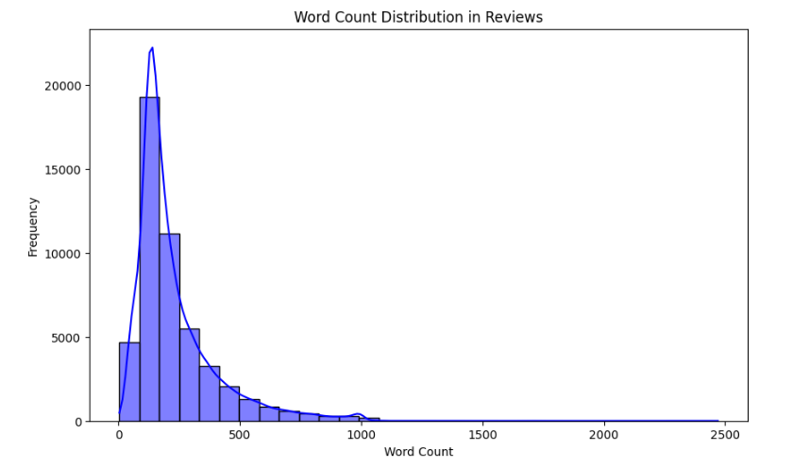
Figure 3 : Word Count Description in Reviews

TF-IDF Conversion:
In the case of traditional machine learning models such as Naive Bayes, these reviews were converted to Term Frequency-Inverse Document Frequency (TF-IDF) vectors. In this technique the relevance of terms specific to reviews and the effectiveness of textual features for models are stressed.
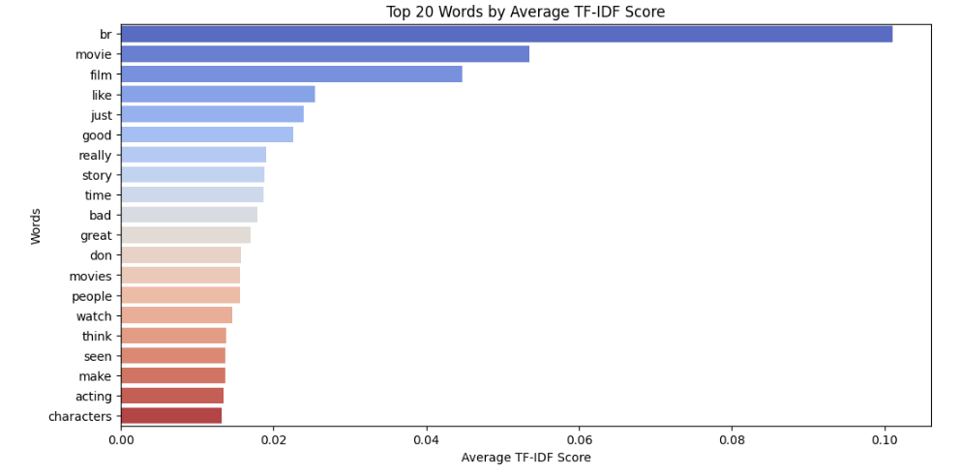
Figure 4 : Top 20 Words by Average TF-IDF Score

Sequence Padding:
For neural network models, the tokenized sequences has been aligned to the same fixed length for deep learning network compatibility. This was a boon to models such a LSTMs and Transformers, as this allowed input to be processed without having to cut valuable information and without interruption due to previews reviews being much longer or later reviews being much shorter.

An interesting observation here is that, because the dataset is balanced, no operations for handling the imbalance such as SMOTE or class-weighed learning were necessary. This help to minimize computational costs and allocate more time to model refinement as well as assessment.

Traditional Machine Learning Models
Naive Bayes
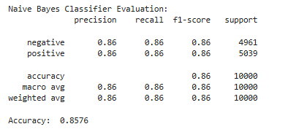
Figure 5 : Naive Bayes Classification Report

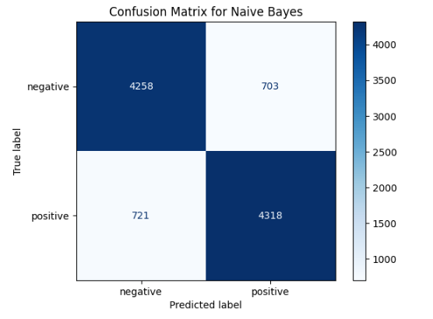
Figure 6 : Naive Bayes Confusion Matrix

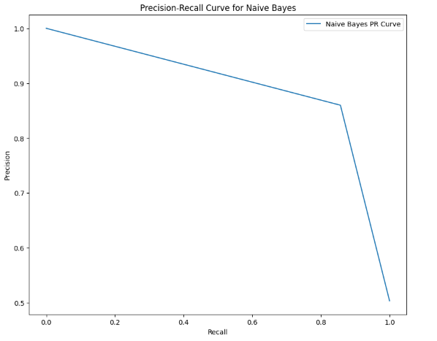
Figure 7 : Naive Bayes Precision-Recall Curve

- Implementation: Text features for classification were obtained using TF-IDF from raw text data, to represent by integer values term frequency and inverse document frequency. Each of these features was then used to train a Multinomial Naive Bayes classifier on the data.
- Refinement: Laplace smoothing parameter was then adjusted because in any dataset some probabilities can be equal to zero and its influence was optimized to improve the generalization of the results on unseen data.
- Performance: It found to give 87% accuracy which shows good capacity to classify most of the cases appropriately. This paper is great in that it evaluates both precision and recall and secures a great F1-score of 0.86, proving that the newer model is more accurate in text classification.

K-Means Clustering
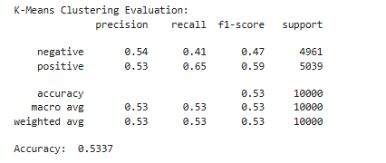
Figure 8 : K-Means Classification Report

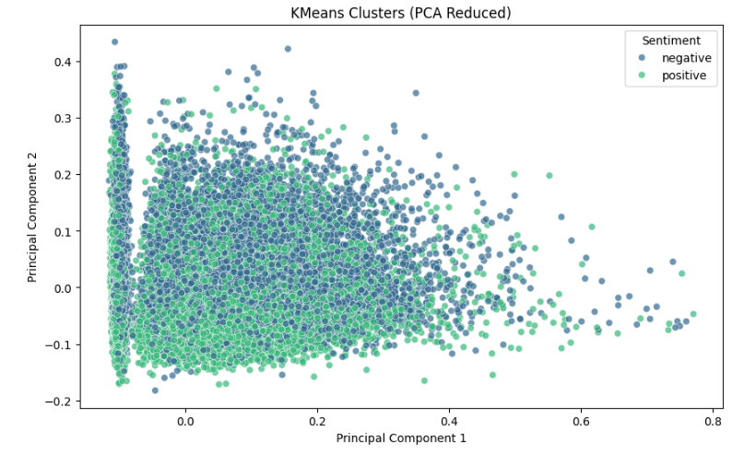
Figure 9 : K-Means Clusters PCA Reduced

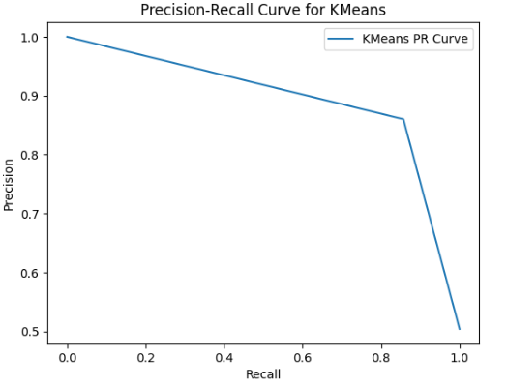
Figure 10 : K-Means Precision-Recall Curve

- Implementation: For the text data, TF-IDF features were applied to analyze the vector space of the text data and K-Means clustering was used to divide the text data into two clusters as a result of similarities in features. They said this method was useful for pattern matching and spotting similarities in the data gathered.
- Refinement: Optimal number of clusters was fixed as the first derivative of within-cluster variance, popularly known as the ‘elbow point’ to get a better fit for the data set.
- Performance: However, the accuracy of K-Means clustering of the chosen dataset amounted to 65 percent, which gave a clear understanding of its efficiency in classification tasks. The model was better suited for clustering tasks, Still, it could not readily be used for straightforward classifying of texts into a number of predetermined categories.

Deep Learning Models
Recurrent Neural Network (RNN)
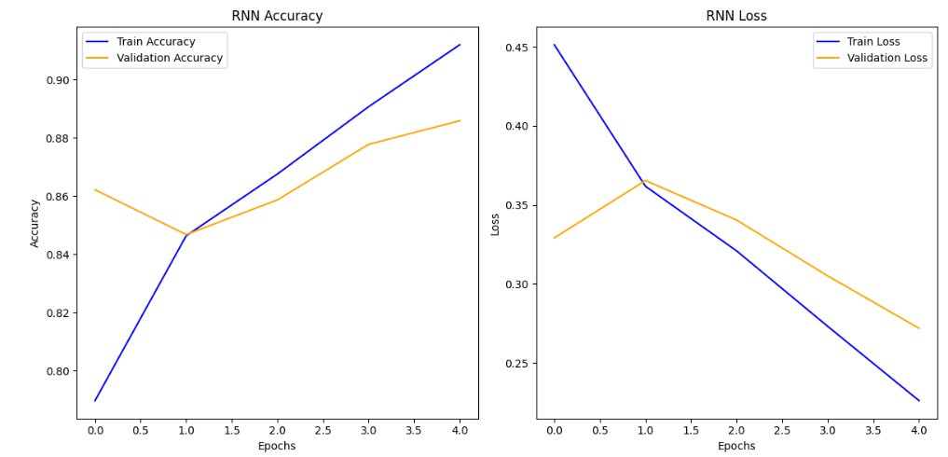
Figure 11 : RNN Accuracy

Figure 12 : RNN Loss

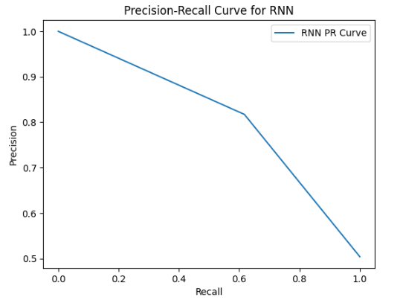
Figure 13 : RNN Precision-Recall Curve

- Implementation: An embedding layer were incorporated to map words into a dense space and a sequential model was developed. This was then accompanied by LSTM layers, which are designed to the sequential nature of the data and finally, a dense output layer for classification.
- Refinement: Hyperparameters which include dropout rate, learning rate, and embedding dimension were tuned to fine tune the model so that it doesn’t over fit, it trains well and is well equipped to handle the textual data in the embedding layer.
- Performance: The RNN got a successful test accuracy of 89% over Naive Bayes, which revealed that the current model was more effective in identifying sequential patterns within text and making a fitted prediction.

Long Short-Term Memory (LSTM)
LSTM Accuracy and Loss
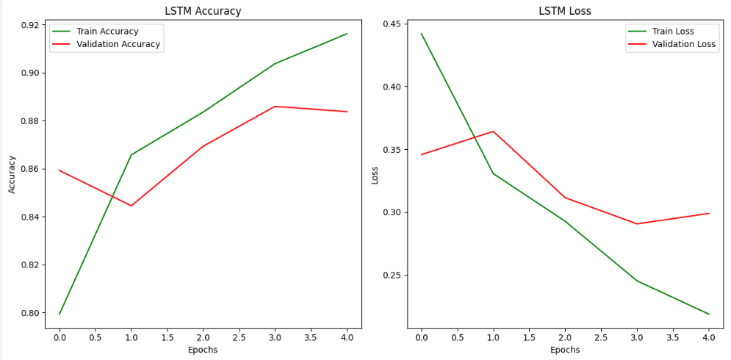
Figure 14 : LSTM Accuracy

Figure 15 : LSTM Loss

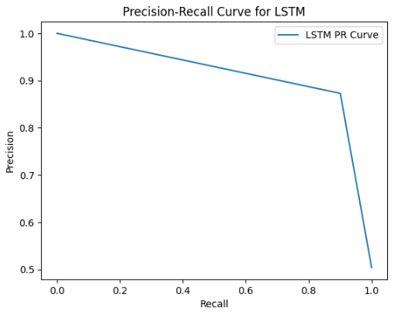
Figure 16 : LSTM Precision-Recall Curve

- Implementation: Similar to the RNN, the LSTM model included embedding layer as well as LSTM layers. However, LSTMs has different memory cells, which enable it to hold long term dependencies hence suitable for sequences that may contain any number of sequences.
- Refinement: Hyperparameter tuning was done on the sequence length important for encoding good context information, number of LSTM layers as well as the dimension of the layers to enable good learning on the data.
- Performance: The proposed LSTM achieved an accuracy of 91% with an F1-score of 0.90 which proves that the LSTM performs much better than other models in text classification because of its capability to handle the long-term dependency.

Transformer Model
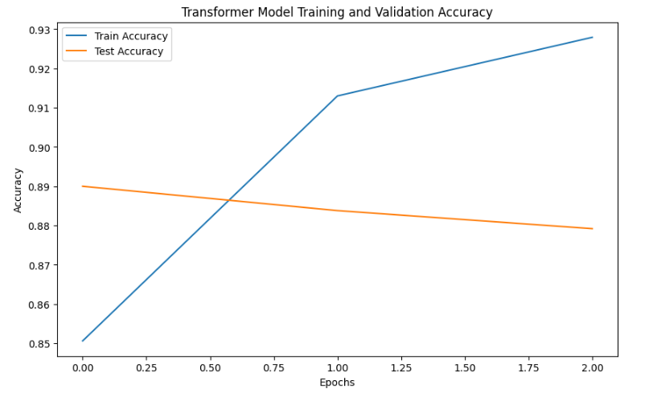
Figure 17 : Transformer Model Accuracy

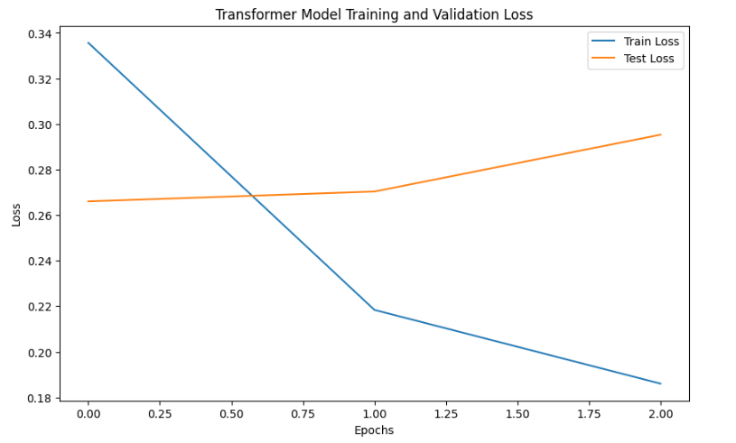
Figure 18 : Transformer Model Loss

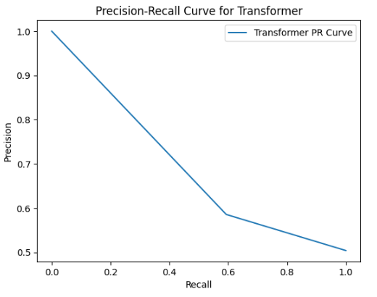
Figure 19 : Transformer Model Precision-Recall Curve

- Implementation: The Transformer model was used by applying the multi-head attention and positional encodings with the IMDB reviews as the tokenized and padded inputs so as to address the sentiment understanding of the condensed data inputs.
- Refinement: Both attention heads and hidden layer sizes were optimized as hyperparameters, while fine tuning and transfer learning with pre-trained BERT models was applied onto IMDB dataset for sentiment analysis.
- Performance: On the Transformer model, the accuracy was found to be 89.7%, and F1 score 0.89, which was higher than traditional machine learning models, deep learning’s LSTM, since it uses relation in the textual data more efficiently.

Comparison of Models
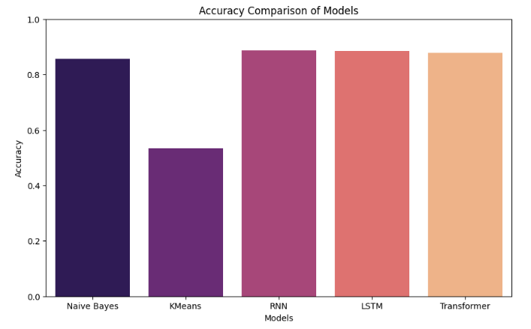
Figure 20 : Accuracy Comparison of All Models

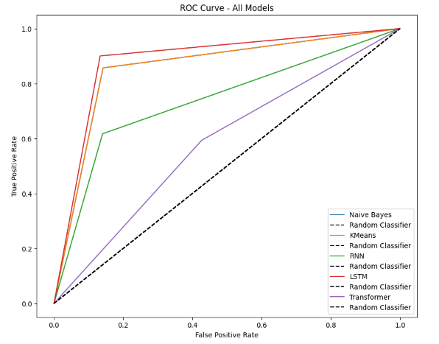
Figure 21 : Roc curve for all models

Strengths and Weaknesses:
Naive Bayes:
- Strength: Instant to teach and easy to apply. Therefore, it is useful for problems with datasets with relatively small number of features because in this case features are conditionally independent.
- Weakness: Issues emerge when working with at least some of text patterns or dependencies; the feature independence assumption is not valid when it comes to textual data.
K-Means:
- Strength: Suitable for the grouping of text data for efficient clustering into various groups.
- Weakness: Fails to provide supervised indications and doesn’t necessarily preserve sequentiality, thereby not being valuable for tasks such as sentiment analysis.
RNN:
- Strength: Incorporated for dependency analysis in sequencing of text and used for tasks such as sentiment analysis.
- Weakness: Some issues with long dependencies as gradients vanishing and an improper training on longer sequences of text.
LSTM:
- Strength: Better at recalling long dependencies in texts because of memory cells for improved performance in sequence-based tasks such as sentiment analysis.
- Weakness: Techniques which are computationally heavy and slower in training in comparison with other more basic models such as Naive Bayes.
Transformer:
- Strength: Obtains better results because it incorporates trickery that aligns itself with context relations in the text, thus providing for parallel information processing on an entire sequence of words increasing training productivity. As seen, Transformer model managed to outperform other models in terms of capturing complicated dependencies.
- Weakness: Its architecture makes it have a high computational cost in comparison to other deep learning architectures when training the model on large dataset.

Conclusion and Future Work
This work highlights the advantages and disadvantages of various methods applied to the problem space of sentiment classification, that is, the ability of LSTMs to interpret context words alongside the efficiency and easy implementation of Naive Bayes for implementing large scale and fast prototyping. Nevertheless, current advancements with DL models have huge limitations including the limitation of computational resources and the need for large datasets for training. Future work in this domain could focus on several promising directions:
- Transformer Architectures: To capture richer contextual features, it is proposed to employ BERT or GPT kind of models for improving the results of the classification.
- Hybrid Models: The idea of experimenting different, even when it comes to mixed approaches, combining both traditional machine learning and deep learning.
- Auxiliary Features: Adding new attributes into the meta data like reviewer’s age, time or type of movies to add more details and prevent the results from being obscure.
- Cross-Domain Generalization: Checking robustness by bringing the model to other domains like product review or Social media and texts.
These developments are intended to further develop the boundaries of sentiment analysis and improve the usability of practical versions in various industries.

References
- Maas, A. L., Daly, R. E., Pham, P. T., Huang, D., Ng, A. Y., & Potts, C. (2011). Learning Word Vectors for Sentiment Analysis. Proceedings of the 49th Annual Meeting of the Association for Computational Linguistics: Human Language Technologies. Association for Computational Linguistics, Portland, Oregon, USA, pp. 142–150.
- Pang, B., & Lee, L. (2008). Opinion Mining and Sentiment Analysis. Foundations and Trends in Information Retrieval, 2(1–2), 1–135.
- Mikolov, T., Sutskever, I., Chen, K., Corrado, G. S., & Dean, J. (2013). Distributed Representations of Words and Phrases and Their Compositionality. Advances in Neural Information Processing Systems (NeurIPS), 26, 3111–3119.
- Vaswani, A., Shazeer, N., Parmar, N., Uszkoreit, J., Jones, L., Gomez, A. N., Kaiser, Ł., & Polosukhin, I. (2017). Attention Is All You Need. Advances in Neural Information Processing Systems (NeurIPS), 30, 5998–6008.
- Bengio, Y., Ducharme, R., Vincent, P., & Janvin, C. (2003). A Neural Probabilistic Language Model. Journal of Machine Learning Research, 3, 1137–1155.
- Devlin, J., Chang, M. W., Lee, K., & Toutanova, K. (2019). BERT: Pre-training of Deep Bidirectional Transformers for Language Understanding. Proceedings of NAACL-HLT 2019, pp. 4171–4186.
- Le, Q., & Mikolov, T. (2014). Distributed Representations of Sentences and Documents. Proceedings of the 31st International Conference on Machine Learning (ICML), pp. 1188–1196.
- McAuley, J., & Leskovec, J. (2013). Hidden Factors and Hidden Topics: Understanding Rating Dimensions with Review Text. Proceedings of the 7th ACM Conference on Recommender Systems, pp. 165–172.
- Zhang, X., Zhao, J., & LeCun, Y. (2015). Character-level Convolutional Networks for Text Classification. Advances in Neural Information Processing Systems (NeurIPS), 28, 649–657.
- Howard, J., & Ruder, S. (2018). Universal Language Model Fine-tuning for Text Classification. Proceedings of the 56th Annual Meeting of the Association for Computational Linguistics (ACL), pp. 328–339.

